MEMORANDUM FOR TRAFFIC REGULATIONS

PROHIBITION AGAINST PARKING (Except for the Handicapped):

Street, etc.: South Dorchester Ave.

Location, etc.: No. 8241 (Permit No. 108135)
(W.O. #H21-1511)

Distance or extent:

Hours: at all times

Days: no exception

James York

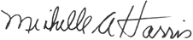
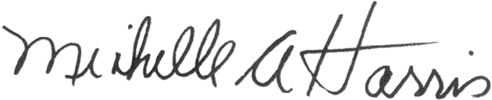

MICHELLE A. HARRIS
Alderman, 8th Ward

