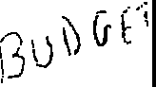

LO.RI E. LIGHTFOOT
MAYOR
OFFICE OF THE MAYOR
CITY OF CHICAGO

April 19, 2023

TO THE HONORABLE, THE CITY COUNCIL OF THE CITY OF CHICAGO

Ladies and Gentlemen:

At the request of the Budget Director, l transmit herewith an ordinance to appropriate Opioid and Vaping settlement funds.

Your favorable consideration of this ordinance will be appreciated.

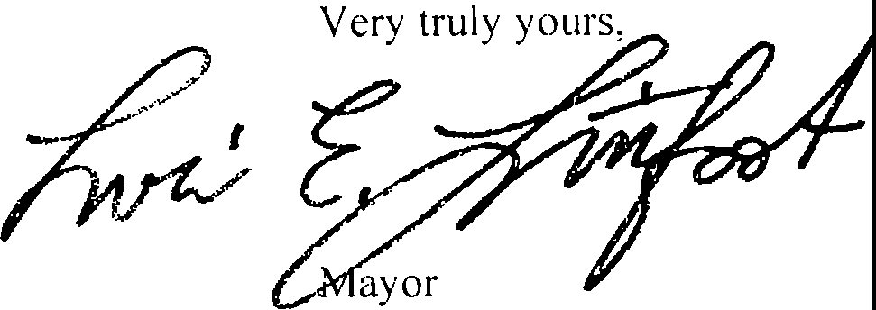

ORDINANCE

BE IT ORDAINED BY THE CITY COUNCIL OF THE CITY OF CHICAGO:

SECTION 1. The 2023 Annual Appropriation Ordinance is hereby amended by striking the words and figures indicated and by inserting the words and figures indicated on Exhibit A and Exhibit B attached hereto.

SECTION 2. This ordinance shall take effect 10 days after its passage and publication.

AMENDMENT TO 2023 ANNUAL APPROPRIATION ORDINANCE Exhibit A

0B89 - Opioid Settlement Fund

PAGE CODE | DEPARTMENT AND ITEM | STRIKE  NUMBER AMOUNT | ADD  NUMBER AMOUNT
31 | Opioid Settlement |  | $ 16,000,000

Exhibit A

Opioid Settlement Fund-0B89
AMENDMENT TO 2023 ANNUAL APPROPRIATION ORDINANCE

STRIKE

ADD

tode Department and Item
-----·······--· ---------
Number Amount Number Amount
-------··------------------

41-Chicago Department of Public Health Department of Public Health-1005
.0006 Salary Provision
.0135 For Delegate Agencies
.0140 For Professional and Technical services and other Third Party Benefit Agreements
.0150 Publications and Reproduction - outside services. To Be Expended with the Prior Approval of Graphics services
.0181 Mobile Communication services
.0245 Reimbursement to Travelers
.0340 Material and supplies
.0446 For the Purchase of Data Processing, office Automation and Data Communication Hardware

1,152,470
10,588,331
750,000
35,000

4,380
15,000
550,684
30,000

opioid/substance use Prevention-3037

3467 | Public Health Administrator | III | 2 | 78,252
3466 | Public Health Administrator | II | 2 | 64,992
3408 | Epidemiologist IV |  |  | 97,260
3057 | Director of Program operations |  | 3 | 125,000
2989 | Grants Research specialist |  |  | 77,772
1431 | senior Policy Analyst |  |  | 88,308
1301 | Administrative services officer I |  | 2 | 59,184
0729 | Information coordinator |  |  | 69,984
0620 | GIS Analyst |  | 2 | 59,184
0613 | GIS Manager |  |  | l 00,848
0431 | Clerk IV |  |  | 44,808
0380 | Director of Administration I |  |  | 64,992
0313 | Assistant Commissioner |  | 2 | 114,000
0311 | Projects Administrator |  |  | 125,000
0311 | Projects Administrator |  | 4 | 100,000
0308 | Staff Assistant |  | 2 | 59,184
0124 | Finance Officer |  |  | 77,772

Exhibit A

Opioid Settlement Fund-0889
AMENDMENT TO 2023 ANNUAL APPROPRIATION ORDINANCE

STRIKE ADD

Code Department and Item
1
99-Finance General

Number Amount Number
Amount _;

.0042 For the Costs of claims and Administration for Hospital and Medical care Provided to Eligible Employees, Provided However, That All Payments to the Independent Utilization Reviewer shall Be subject to the Approval of the chairman of the committee on the Budget and Government operations
.0045 For the cost of claims and Administration or Premiums for Term Life Insurance
.0056 For the cost of claims and Administration or Premiums for a co-Insured Dental Plan for Employees
464,000

3,567
15,232

AMENDMENT TO 2023 ANNUAL APPROPRIATION ORDINANCE Exhibit B

0B90 - Vaping Settlement Fund

PAGE CODE | DEPARTMENT AND ITEM | STRIKE  NUMBER AMOUNT | ADD  NUMBER AMOUNT
31 | Vaping Settlement |  | $ 2,000,000

Exh1b1t B

AMENDMENT TO 2023 ANNUAL APPROPRIATION ORDINANCE
Vaping Settlement Fund-0B90

STRIKE ADD
··------- ------

- ,

Code Department and Item
Number Amount

Number
·····
 | 41C-hicago Department of Public Health | ····
 | Department of Public Health-1005
.0006 | Salary Provision |  |  | 111,044
.0135 | For Delegate Agencies |  |  | 900,000
.0140 | For Professional and Technical services | and other |  | 733,000
.0150 | Publications and Reproduction - outside services. |  |  | 40,000
.0190 | services  Telephone - Centrex Billings |  |  | 450
.0245 | Reimbursement to Travelers |  |  | I 0,000
.0340 | Material and Supplies |  |  | 13,790

Amount !

T ird Party Benefit Agreements
To Be Expended with the Prior Approval of Graphics

.0446 For the Purchase of Data Processing, office Automation and Data Communication Hardware
4,676

chronic Disease-3036
3752 Public Health Nurse II
3467 Public Health Administrator III

75,492
78,252

Exh1b1t B

AMENDMENT TO 2023 ANNUAL APPROPRIATION ORDINANCE
Vaping Settlement Fund-0B90

:code _Department and Item
99-Finance General
STRIKE ADD

Number Amount Number Amount

.0042 For the costs of claims and Administration for Hospital and Medical care Provided to Eligible Employees, Provided However, That All Payments to the Independent Utilization Reviewer shall Be subject to the Approval of the Chairman of the committee on the'Budget and Government operations
.0045 For the cost of claims and Administration or Premiums for Term Life Insurance
.0056 For the cost of claims and Administration or Premiums for a co-Insured Dental Plan for Employees
32,000

246
1,050

