RESOLUTION

WHEREAS, Daniel Ellsberg risked life in prison to reveal secret, illegal, and immoral activities to the people of the United States and the rest of the world by giving the Pentagon Papers to the U.S. Congress and news media;

WHEREAS, Ellsberg’s actions contributed to ending the war in Vietnam, and to discouraging further war-making, including by informing the public of the inner workings of the U.S. government;

WHEREAS, further revelations made by Ellsberg over many years greatly informed the public of the dangers of nuclear weaponry;

WHEREAS, Daniel Ellsberg has been for decades an outstanding educator and activist on some of the most important issues facing the Earth;

WHEREAS, Daniel Ellsberg has supported, encouraged, and inspired whistleblowers, journalists, and activists all over the world;

WHEREAS, the Bulletin of the Atomic Scientists has placed its Doomsday Clock measurement of the current risk of nuclear war higher than it has ever been before, and every means of awakening people to the danger is merited;

BE IT RESOLVED, we, the City of Chicago, designate April 24-30 as Daniel Ellsberg Week in Chicago, and encourage during this week the reading of Daniel Ellsberg’s books, articles, and interviews, and the viewing of his films and videos, some of which can be found at defusenuclearwar.org/ellsberg.
”
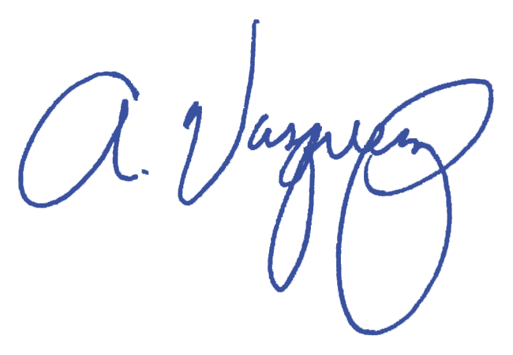
Andre Vasquez, Jr.
Alderman, 40th Ward

